**Measuring *Lysiphlebus fabarum* wings**

1. Download ImageJ (free software, download here -<https://imagej.nih.gov/ij/download.html>)
2. First open image of scale bar for that set of photos in ImageJ
3. Click on the line tool on the grey toolbar

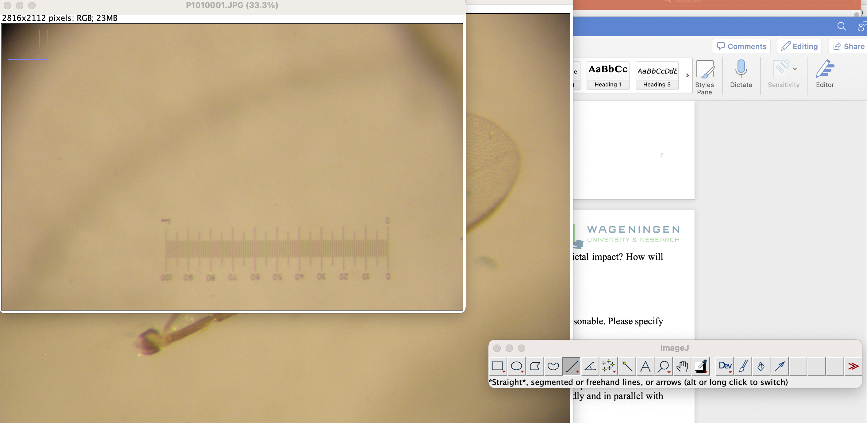

1. Then click on one end of the scale bar, move the cursor across to the other end and click again.
   1. You will see some numbers (x=, y=, angle=, length=)
   2. Get the angle to 0
   3. Then record the number next to length =

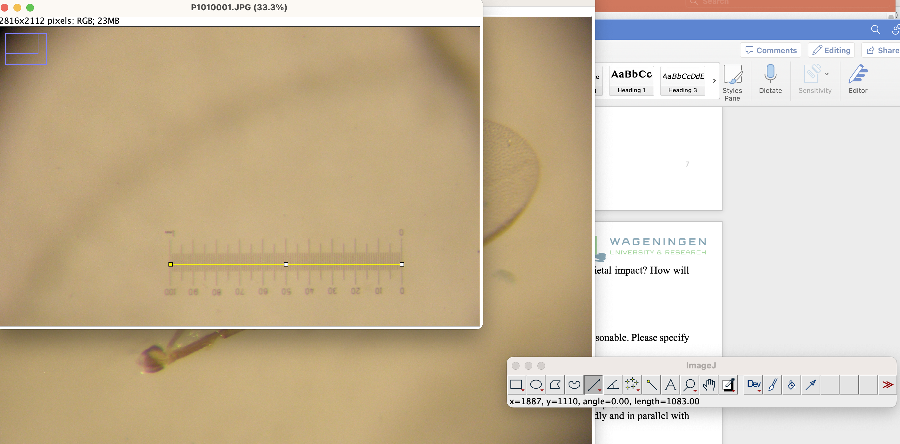

1. At the top toolbar click ‘Analyze’ and scroll down to ‘Set Scale’

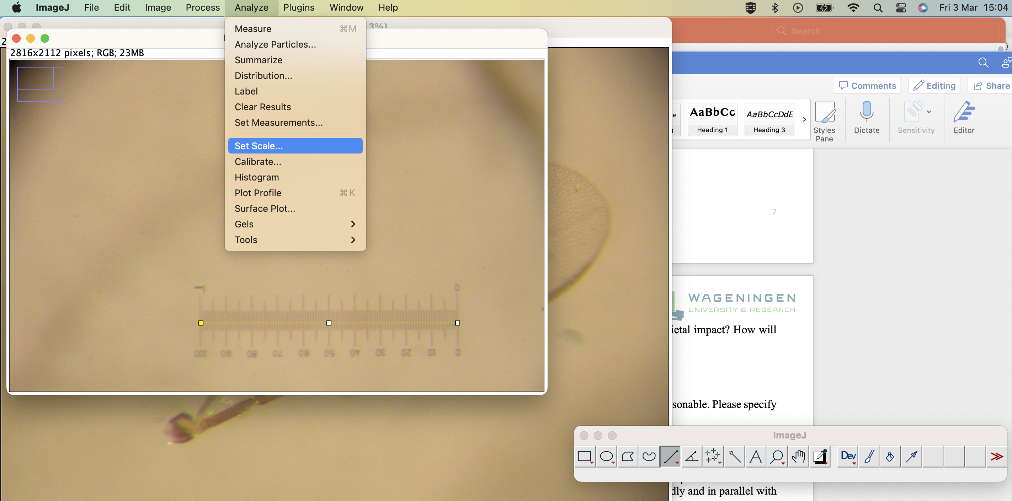

* 1. In the box that opens under ‘distance in pixels’ type the value for length
  2. Under known length write in ‘1000’
  3. Under unit of length write ‘uM’
  4. Select the ‘global’ check box

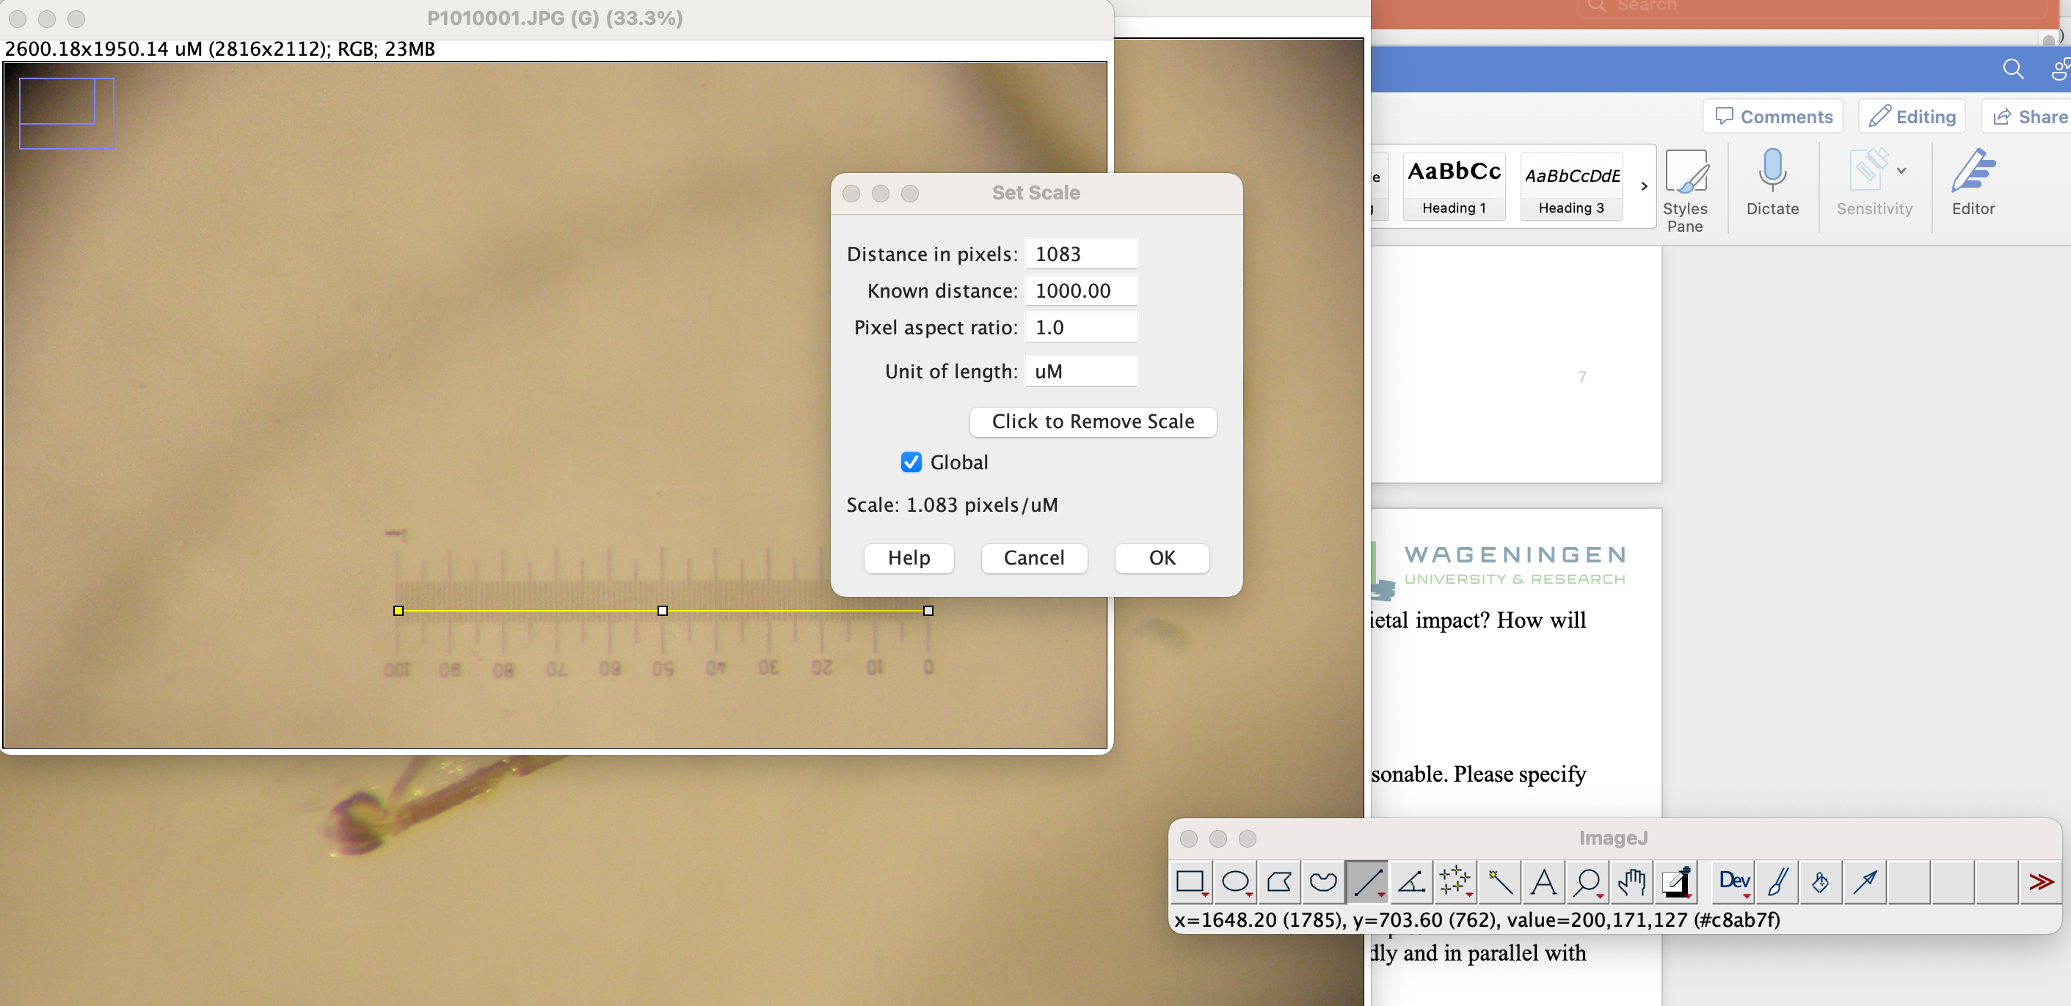

Re-measure the scale line (4)

* 1. The line should now measure about 1000.00 (uM) - shown in uM not pixels

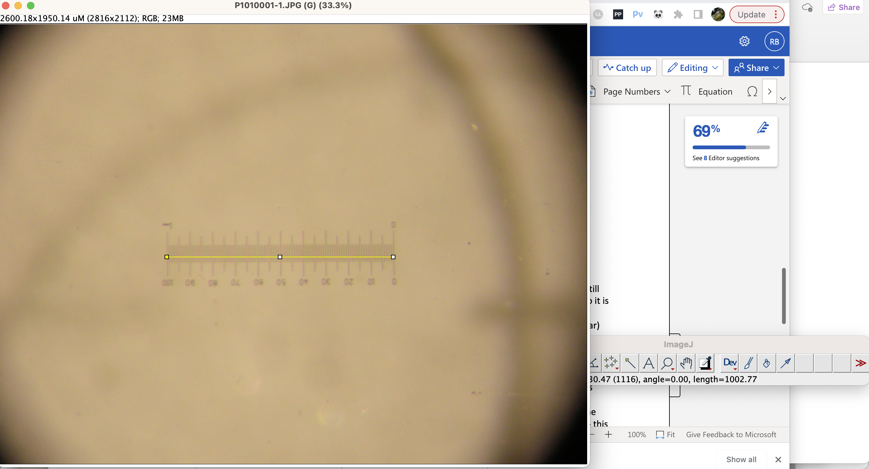

1. Now open the first image of a bee wing
   1. Select the analyze/set scale option and check whether the measurement is still the same as in the previous image (the decimal point might have changed, so it is 1.00 known distance to 1.083 pixels, but this is fine)

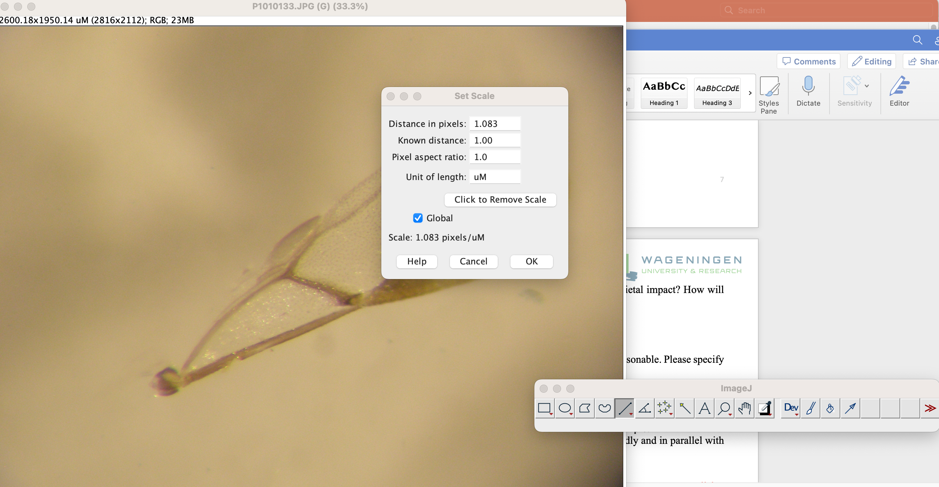

* 1. Select the line tool again and measure (using the length= value on the tool bar)
     1. The longest part of the bee wing (from base to tip)
     2. Point A-B
     3. Point B-C

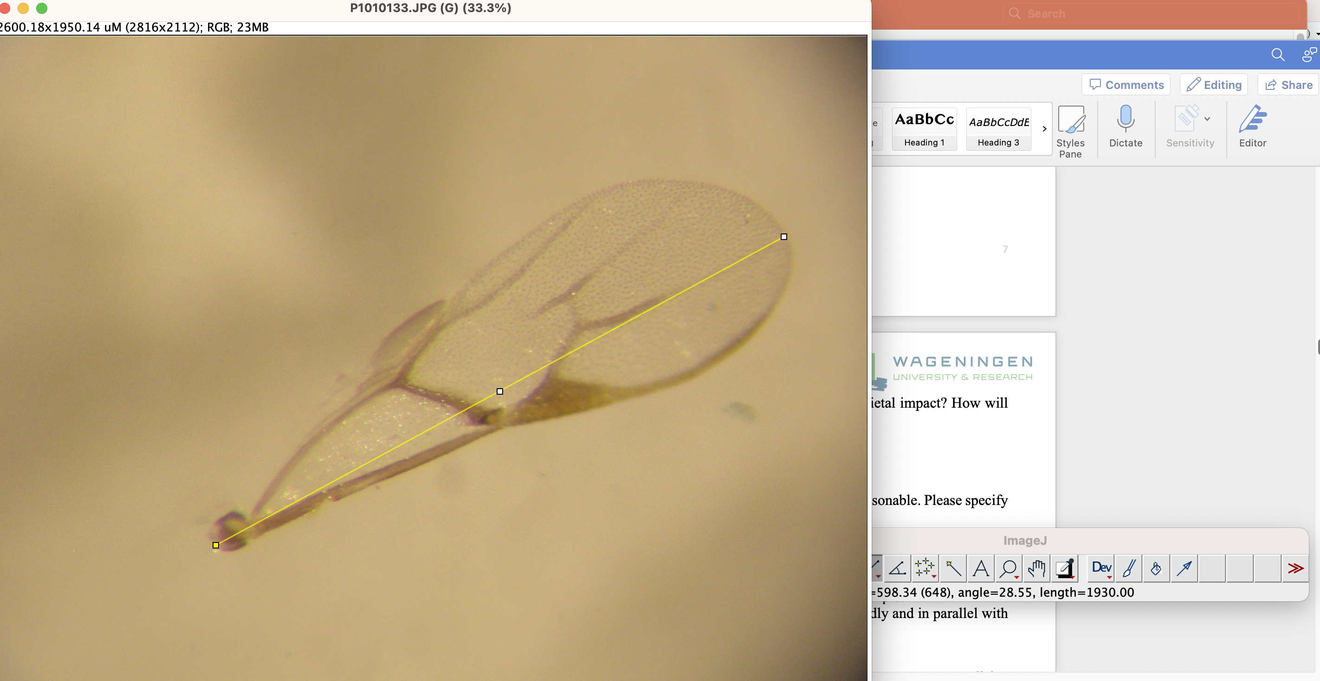

* + - 1. Record the length of each next to the photo ID on this spreadsheet [Raw data - 3.2.23.xlsx](https://stir-my.sharepoint.com/:x:/r/personal/rb76_stir_ac_uk/Documents/Lysiphlebus/Experiments/LMC%20Jan%202023/Raw%20data%20-%203.2.23.xlsx?d=w38d014c6fefc4c84a5f67178a7d6b2c7&csf=1&web=1&e=x6VJKA) in the Wing-measurements tab
         1. Record your name and when you measured the wing in the column next to it
      2. For every 1 in 10 photos take the measurements 3 times (come back to the same image after you’ve measured some others) - this will allow us to calculate measurement error in all the 3 values.

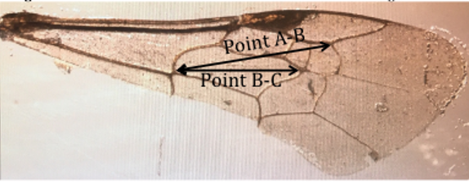

Distances to measure (as measured on a bee wing)

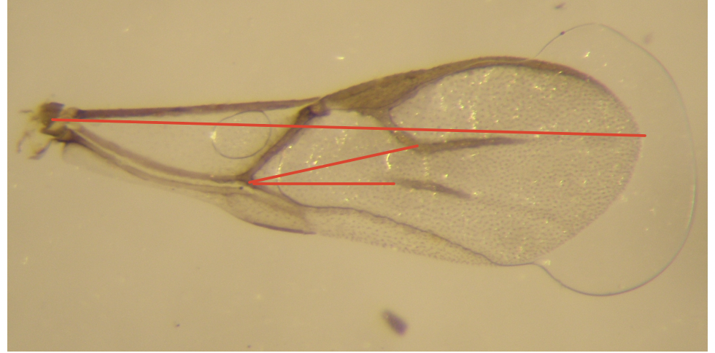

How it looks on a Lysiphlebus wing